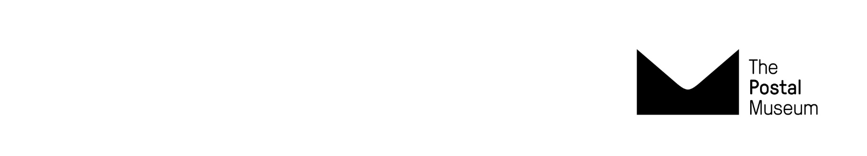
Terms and conditions for schools
Museum Visits 2024-2025

Terms and conditions apply to all schools and learning groups.

Booking

- Booking is essential for schools and learning groups. Teachers must complete the booking request form in full. We will email within one week to confirm/discuss your booking request. Check your booking confirmation email carefully. Get in touch asap if any information is incorrect.
- Payment in full is due in advance within 30 days from the date of your booking confirmation email. Schools can book at shorter notice depending on availability. In this case payment is expected before the visit date and may be requested immediately. Schools will receive an invoice by email. Payment is by BACS transfer or cheque. If timely payment is not made bookings may be cancelled.
- Booking changes may be possible depending on availability. All changes to your itinerary and group size must be requested by email before the visit date. If we can accommodate the changes this will be confirmed by email. Schools that bring additional students/adults may be asked to pay full student/adult rates (at the discretion of the museum).

Cancellations
School cancellations received in writing up to 30 days from the date on your booking confirmation email will incur no charge and a full refund. We cannot guarantee to move bookings or provide refunds after this point and schools may be charged 100% of the visit cost.
Museum cancellations may occur in rare unforeseen circumstances. We will contact schools as soon as we can and offer alternative visit dates or a full refund. Regrettably we cannot reimburse travel or other costs.
Late arrivals
- Late arrivals will not receive a refund. Check your journey time for travel delays and call us asap if your route is affected. A late start to a visit is at the museum’s discretion and we cannot guarantee to offer your full itinerary.
Health and safety
- Risk assessments are the responsibility of teachers. Teachers can request a free planning visit. Our website includes risk assessment guidance notes for Mail Rail and Sorted!
Behaviour and supervision
- Disruptive behaviour in the museum may result in a group being asked to leave, accompanied by their teacher. We will not provide a refund in these circumstances.

Safeguarding
- Schools must bring the required ratio of adults: students and keep to these ratios at all times.
The Postal Museum’s Safeguarding Policy can be downloaded here.
Personal belongings
- We accept no responsibility for loss, theft or damage to personal items.
Photography
- We welcome photography but flash and selfie sticks are prohibited. We politely ask you not to film The Postal Museum staff and volunteers on phones or tablets.

Got a question for us?
Email schools@postalmuseum.org
Call 0300 0300 700 (Monday - Friday 10.00 – 17.00)

